User Interface Meeting Minutes

Date: Feb 21, 2022

Attendees: Vedang Kathari, Elizabeth Neff, Jordon Oja, Jason Lazarra, Gary Chopcinski

Updated: G. Chopciinski Feb 28, 2022

* Insert Mouthpiece
* All text needs to be centered top to bottom.

[chop] The goal is to present a pleasing appearance.

Liz and Jason like the left picture because it’s more consistent with the sentence case of the other screens.

[chop] So beit.

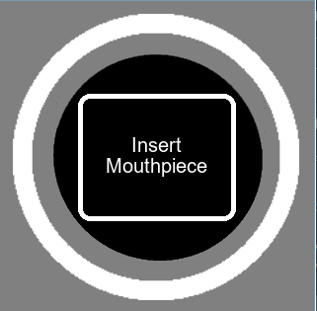 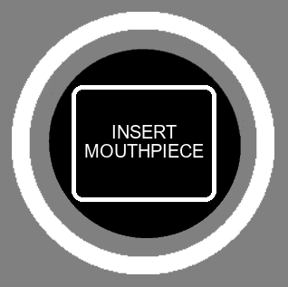

NOTE the appearance of Upper/Lower case mixed characters vs Uppercase only characters.

* Reading
* Might want more than just the word “Reading” but there might not be enough time to say more

[chop] What verbiage do we want here?

Good as is

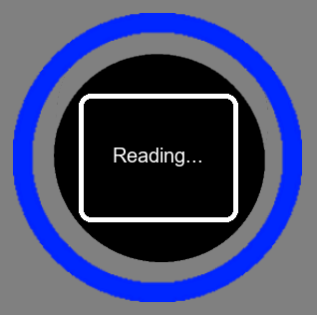

  

* Serial Number: MCA010001 Press play/pause if correct
* Center Serial Number: MCA010001 Press play/pause if correct
* ???? Press play/pause or press play
* Instead of “if correct” say “To continue”

[chop] Done.

Press Play/Pause doesn’t seem to be centered on the screen horizontally

[chop] done.

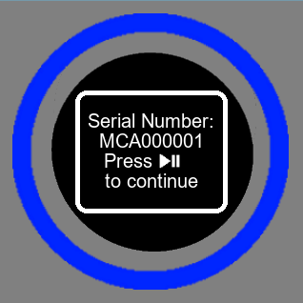 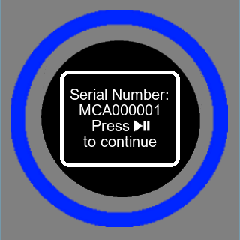

I changed “To” to “to” for appearance.

* Ready Press play
* Needs to be centered both top to bottom and left to right
* “Ready to start therapy?” Press play / press play to start therapy

[chop] Done

Can “to Start Therapy” fit on a single line? Otherwise, screen looks good.

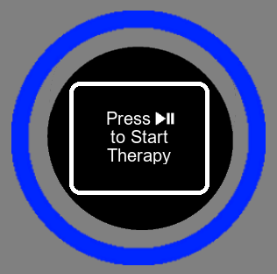   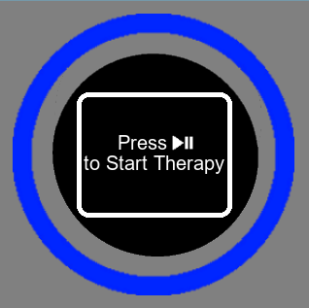  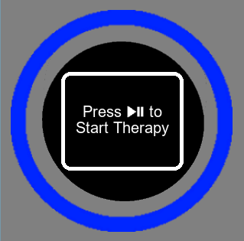

Choices are wonderful! 3 lines or 2 lines. Left, Center, Right?

* Operation
* Scroll or tick method?

[chop] tick method is chosen.

* Countdown, needs to include seconds and not look like there is an additional minute

[chop] Clarify, please.

Please confirm that an extra minute is not being displayed. For example at 4 min 29 secs the tick marks should be at 29 and the min is at 4 min.

[chop] It counts 4, 3, 2, 1, 0.

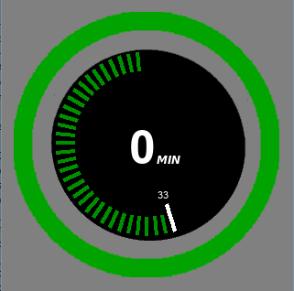

* The word “operation” is new do we like that?

[chop] “Operation” is deleted.

* Wants to get rid of the word operation and add the word “min” next to the numbers

[chop] “Operation” is deleted. “MIN” is added.

* Scrolling the whole time instead of a minute at a time    
  Need to think about it but according to people now they like the ticks at each minute   
  [chop] Clarify, please.

The screen below looks correct, no action needed.

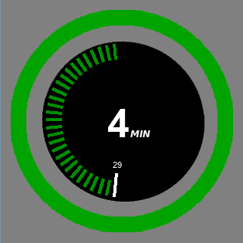

* Paused
* Show the seconds

[chop] The seconds are shown by the white tick.

* Keep the ticks on when paused

[chop] Done

Paused screen looks correct

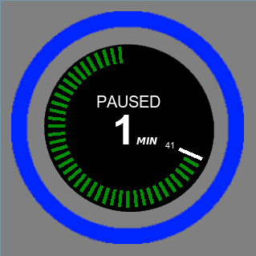

* Error
* Ring needs to be red

[chop] Done.

* Red text and red border

[chop] Done

* Tick marks need to disappear when error

[chop]

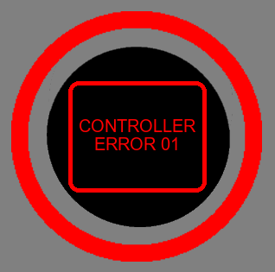  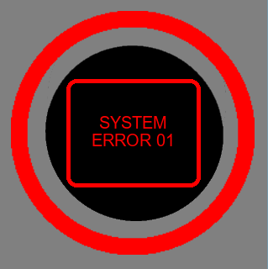

I changed “CONTROL UNIT” to “CONTROLLER” for screen appearance. Maybe we can use “SYSTEM ERROR”.

Like the verbiage “SYSTEM ERROR ##”

[chop] Done

* Mouthpiece Reading Error
* “Reading Error Reinsert Mouthpiece”

[chop] Done, IN RED…. Do we want it white?

We want it in Red, change to uppercase.

[chop] Done.

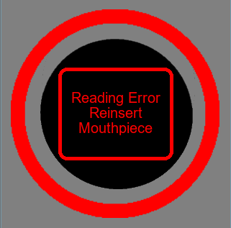  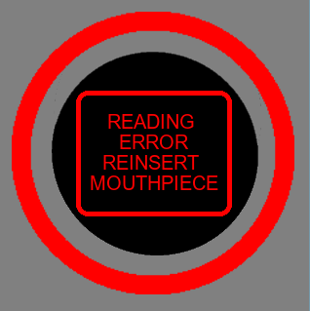

* Mouthpiece Reading Error Occurs During Operation phase
  + Flow is not correct

Newest flow chart is correct

* + Needs “Mouthpiece detached”

[chop] Need to do.

Needs to be uppercase, red

* Mouthpiece Reading determines that the MCA is Expired
  + Font and border need to be red

[chop] Done.

Needs to be uppercase

[chop] Done

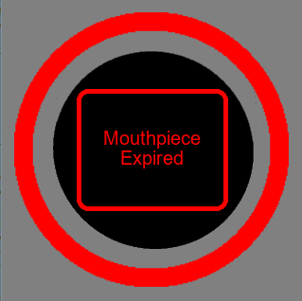   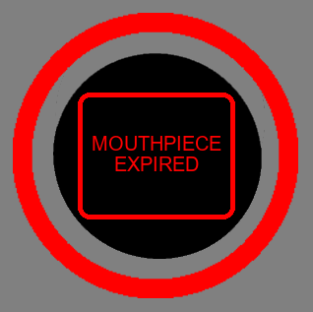

* Time stamp
  + Need to talk to Sam if the time stamp is supposed to be there and if we’re doing it moving forward
  + Needs to throw an error code if we keep the time stamp…need to come up with wording

[chop] Need to do. Sam wants a 12-hour retry constraint added.

“MOUTHPIECE NOT READY”

Needs to be red

[chop] Done

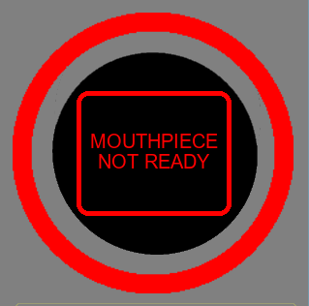

Please, confirm font size is uniform throughout and that it’s bigger than version 1 LCU.